**Linux Task:**

**Setting Up a LAMP Stack on Amazon Linux EC2**

**Security grps**

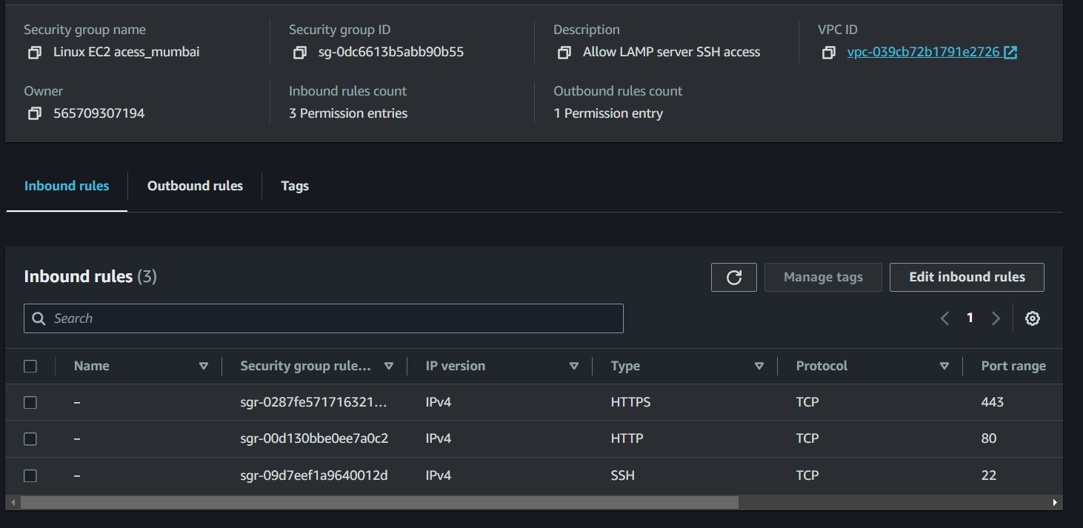

**Allow ssh http and https access**

**Create a PPk/pem key**

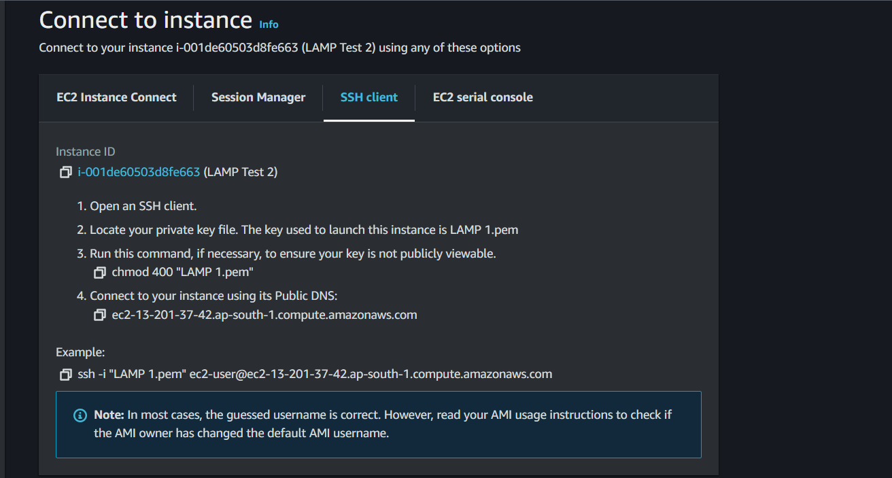

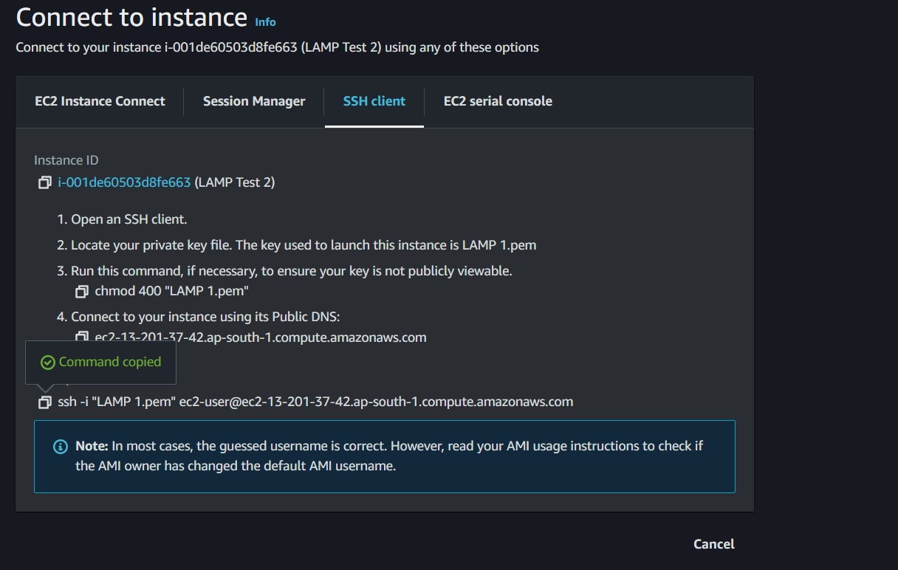

**Launch EC2 instance:**

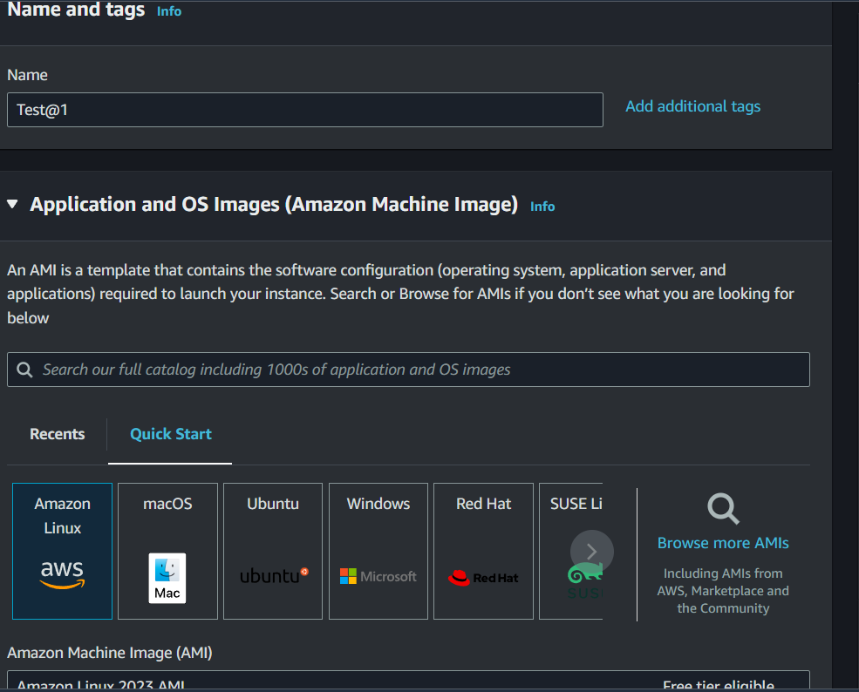

Name the instance and select the AMI

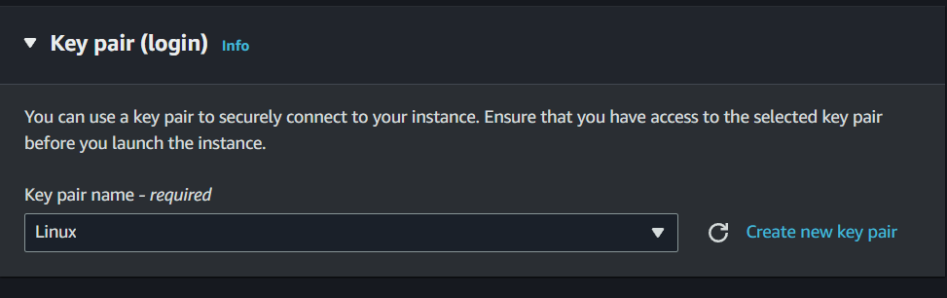

Generate the key pair and download to connect with instance as there is no endpoints connections download and save as once created we cant access the keys

**INSTANCE CONNECTION**

Allow SSH client connection and fill the commands in local machine

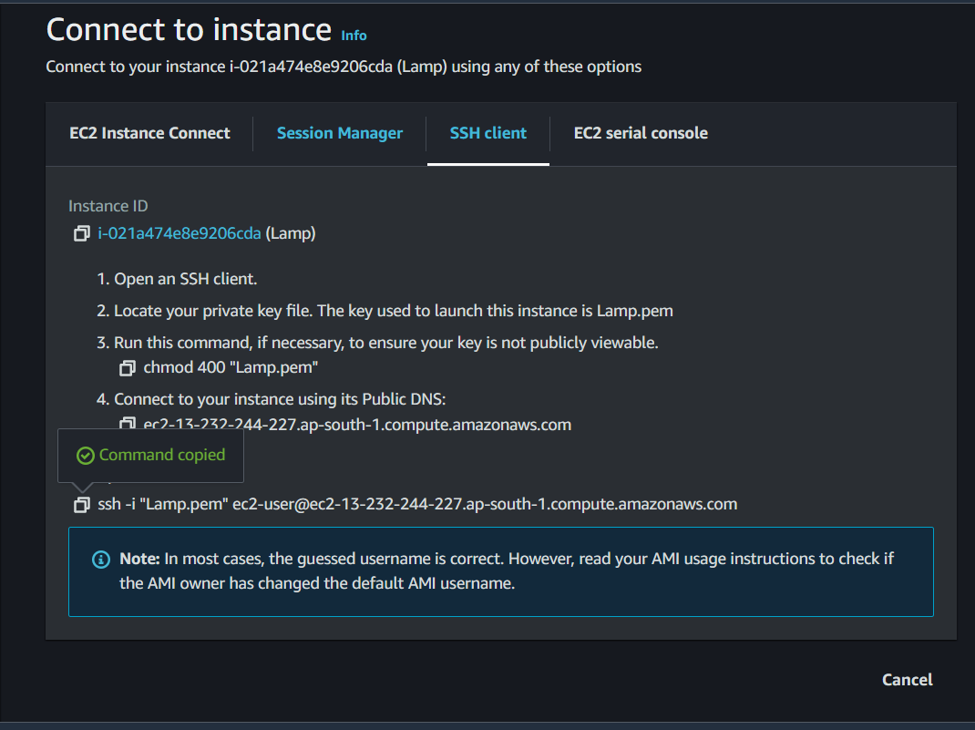

To access vm following commands were used along with pem key created

chmod 400 "Lamp.pem"

ec2-13-232-244-227.ap-south-1.compute.amazonaws.com

above is the instance we want to connect with the pem key authentication

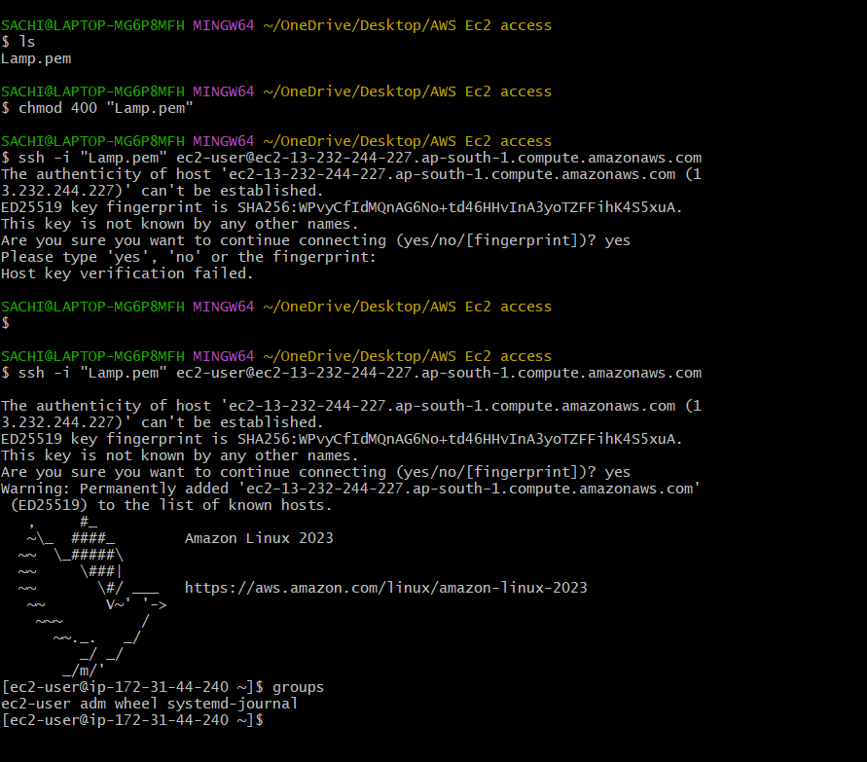

Installing and Configuring Apache on Amazon Linux 2023

1. **Connect to your EC2 instance** using SSH:

**ssh -i /path/to/your-key-file.pem ec2-user@your-ec2-public-ip**

1. Update the package index:

**sudo dnf update -y**

3.Install Apache (httpd):

**sudo dnf install httpd -y**

4: Start and Enable Apache

**sudo systemctl start httpd**

Enable Apache to start on boot:

**sudo systemctl enable httpd**

5: Adjust Firewall Settings

Allow HTTP and HTTPS traffic through the firewall:

**sudo firewall-cmd --permanent --add-service=http**

**sudo firewall-cmd --permanent --add-service=https**

**sudo firewall-cmd –reload**

6: Verify Apache Installation

Check Apache’s status:

**sudo systemctl status httpd**

Verify Apache is running by accessing the public IP of your EC2 instance from a web browser. You should see the Apache Test Page.

curl <http://13.232.244.227> this is my public ip from instance page

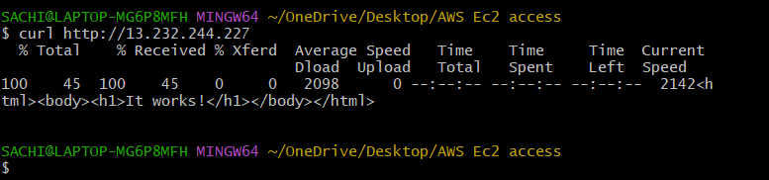

MySQL Installation and Configuration on Amazon Linux 2023

1.Connect to your EC2 instance using SSH:

**ssh -i /path/to/your-key-file.pem** [**ec2-user@13.232.244.227**](mailto:ec2-user@13.232.244.227)

2.Update the package index:

sudo dnf update -y

3.Install the MySQL repository:

**sudo dnf install https://dev.mysql.com/get/mysql80-community-release-el9-1.noarch.rpm -y**

4.Install MySQL:

**sudo dnf install mysql-server -y**

5.Start the MySQL service:

**sudo systemctl start mysqld**

6.Enable MySQL to start on boot:

**sudo systemctl enable mysqld**

7.Retrieve the temporary root password generated during the MySQL installation:

**sudo grep 'temporary password' /var/log/mysqld.log**

8.Log in to MySQL with the temporary password:

**mysql -u root -p**

9.Set a new root password that meets the current policy requirements:

**ALTER USER 'root'@'localhost' IDENTIFIED BY 'NewP@ssw0rd123!';**

10.Verify MySQL Installation

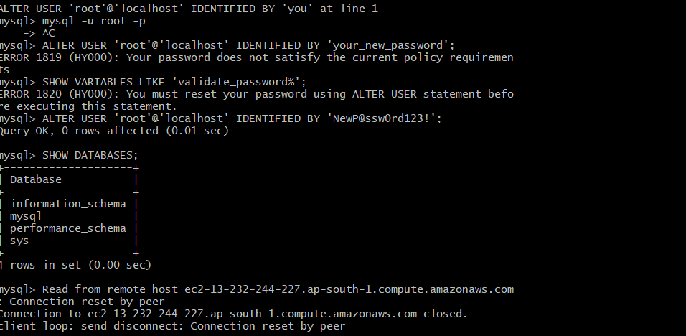

Installing PHP on Amazon Linux 2023

1.Update the package index:

**sudo dnf update -y**

2.Install PHP and modules:

**sudo dnf install php php-mysqlnd php-fpm php-json php-mbstring -y**

3. Check PHP version:

**php -v**

4.Restart Apache to apply changes:

**sudo systemctl restart httpd**

